Window - Address

Window - Logo

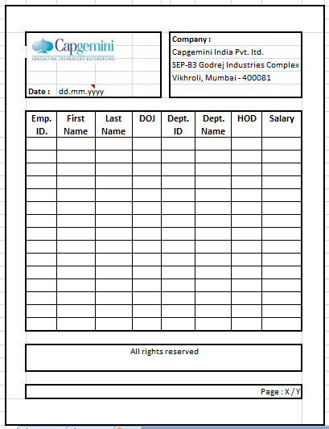

Window - Main

Window - Page

Window - Footer